Current Divider

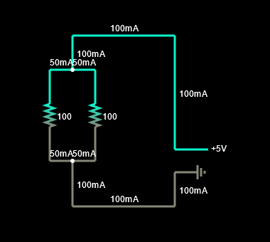

Calculation (First set of values: R1 = 100 Ω & R2 = 100 Ω):

U1 = U1; U1 = I1 x R1; U2 = I2 x R2 → I1 x R1 = I2 x R2; 100 x I1 = 100 x I2 | :100 → I1 = I2; Itotal = I1 + I2 → Itotal = I1 + I1 → Itotal = 2 x I1; Din Ohm's Law for a part of the circuit: I = $\frac{U}{R}$ → Formula for our drawing: In = , where Rn = ; Rn = ; In = ; Knowing that In = 2 x I1 → I1 = ; I1 = 0.5 A = 0.5 x = 500 mA → I2 = I1 = 500 mA

Calculation (The second set of values: R1 = 175 Ω & R2 = 260 Ω):

In = I1 + I2; I2 = In – I1; U1 = U2; U1 = I1 x R1; U2 = I2 x R2 → I1 x R1 = I2 x R2; I1 x R1 = (In – I1) x R2; I1 x R1 = In x R2 – I1 x R2; I1 x R1 + I1 x R2 = In x R2; I1 (R1 + R2) = In x R2; I1 = $\frac{In x R2}{R1+R2}= \frac{220.9 x 26}{175+26}= \frac{5743.4}{201}≅$ 28.6 mA; I2 = In – I1; I2 = 220.9 – 28.6 192.3 mA

Calculation (Third set of values: R1 =340 Ω & R2 = 15 Ω):

In = I1 + I2; I2 = In – I1; U1 = U2; U1 = I1 x R1; U2 = I2 x R2 → I1 x R1 = I2 x R2; I1 x R1 = (In – I1) x R2; I1 x R1 = In x R2 – I1 x R2; I1 x R1 + I1 x R2 = In x R2; I1 (R1 + R2) = In x R2; I1 = $\frac{In x R2}{R1+R2}= \frac{348 x 15}{340+15}= \frac{5220}{355}≅$ 14.7 mA; I2 = In – I1; I2 = 348 – 14.7 333.3 mA